**Hệ Thống Coach BodyBulding**

Manager: (Id_Manager, FullName_Manager, Birthday_Manager, Address_Manager, Phone_Manager, Fbid_Manager)

Customer: (Id_Cus, FullName_ Cus, Birthday_ Cus, Address_ Cus, Phone_ Cus, Fbid_ Cus)

Type_Position: (Id_Pos, Name_Pos)

Alum: (Id_Album, Album _at)

Image: (Id_Image, Image_text, Image_at )

Calendar: (Id_Calendar, Title_Calendar, calendar_at)

Calendar_Detail: (Id_ CalendarDetail, Moring, Noon, Afternoon, Note, Time_alert)

Type_Calendar: (Id_ TypeCalendar, Titrle_ TypeCalendar)

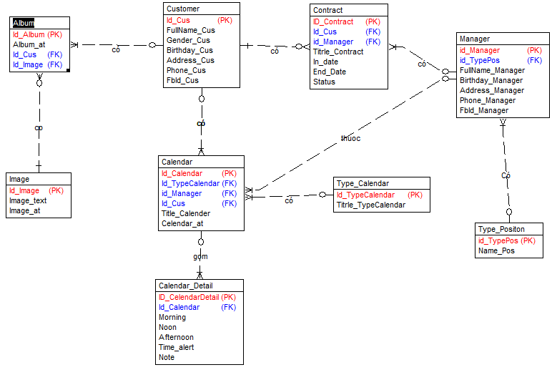

Create table [Customer]

(

[Id_Cus] Integer Identity(1,1) NOT NULL,

[FullName_Cus] Nvarchar(31) NOT NULL,

[Gender_Cus] Bit NOT NULL,

[Birthday_Cus] Datetime NOT NULL,

[Address_Cus] Nvarchar(100) NOT NULL,

[Phone_Cus] Char(12) NOT NULL,

[Identitycard_Cus] Char(1) NOT NULL,

[FbId_Cus] Char(1) NOT NULL,

Primary Key ([Id_Cus])

)

go

Create table [Manager]

(

[id_Manager] Integer Identity(1,1) NOT NULL,

[id_TypePos] Integer NOT NULL,

[FullName_Manager] Nvarchar(31) NOT NULL,

[Birthday_Manager] Datetime NOT NULL,

[Address_Manager] Nvarchar(100) NOT NULL,

[Phone_Manager] Varchar(12) NOT NULL,

[Identitycard_Manager] Nvarchar(20) NOT NULL,

[FbId_Manager] Varchar(255) NOT NULL,

Primary Key ([id_Manager])

)

go

Create table [Type_Positon]

(

[id_TypePos] Integer Identity(1,1) NOT NULL,

[Name_Pos] Nvarchar(31) NOT NULL,

Primary Key ([id_TypePos])

)

go

Create table [Album]

(

[Id_Album] Integer Identity(1,1) NOT NULL,

[Id_Cus] Integer NULL,

[Id_Image] Integer NOT NULL,

[Album_at] Datetime NOT NULL,

Primary Key ([Id_Album])

)

go

Create table [Type_Calendar]

(

[Id_TypeCalendar] Integer Identity(1,1) NOT NULL,

[Titrle_TypeCalendar] Nvarchar(225) NOT NULL,

Primary Key ([Id_TypeCalendar])

)

go

Create table [Calendar]

(

[Id_Calendar] Integer Identity(1,1) NOT NULL,

[Id_Cus] Integer NULL,

[Id_TypeCalendar] Integer NOT NULL,

[id_Manager] Integer NOT NULL,

[Day_DoingGym] Datetime NOT NULL,

[Titrle_Calendar] Nvarchar(50) NOT NULL,

[Calendar_at] Datetime NOT NULL,

Primary Key ([Id_Calendar])

)

go

Create table [Contract]

(

[Id_Contract] Integer Identity(1,1) NOT NULL,

[Id_Cus] Integer NULL,

[Titrle_Contract] Nvarchar(50) NOT NULL,

[In_date] Datetime NOT NULL,

[end_date] Datetime NOT NULL,

[Status] Bit NOT NULL,

[id_Manager] Integer NOT NULL,

Primary Key ([Id_Contract])

)

go

Create table [Image]

(

[Id_Image] Integer Identity(1,1) NOT NULL,

[Image_text] Datetime NOT NULL,

[Image_at] Datetime NOT NULL,

Primary Key ([Id_Image])

)

go

Create table [Calendar_Detail]

(

[Id_CalendarDetail] Integer Identity(1,1) NOT NULL,

[Id_Calendar] Integer NOT NULL,

[Morning] Nvarchar(225) NOT NULL,

[Noon] Nvarchar(225) NOT NULL,

[Afternoon] Nvarchar(225) NOT NULL,

[Time_alert] Datetime NOT NULL,

[Note] Text NOT NULL,

Primary Key ([Id_CalendarDetail])

)

go

Alter table [Album] add foreign key([Id_Cus]) references [Customer] ([Id_Cus]) on update no action on delete no action

go

Alter table [Contract] add foreign key([Id_Cus]) references [Customer] ([Id_Cus]) on update no action on delete no action

go

Alter table [Calendar] add foreign key([Id_Cus]) references [Customer] ([Id_Cus]) on update no action on delete no action

go

Alter table [Calendar] add foreign key([id_Manager]) references [Manager] ([id_Manager]) on update no action on delete no action

go

Alter table [Contract] add foreign key([id_Manager]) references [Manager] ([id_Manager]) on update no action on delete no action

go

Alter table [Manager] add foreign key([id_TypePos]) references [Type_Positon] ([id_TypePos]) on update no action on delete no action

go

Alter table [Calendar] add foreign key([Id_TypeCalendar]) references [Type_Calendar] ([Id_TypeCalendar]) on update no action on delete no action

go

Alter table [Calendar_Detail] add foreign key([Id_Calendar]) references [Calendar] ([Id_Calendar]) on update no action on delete no action

go

Alter table [Album] add foreign key([Id_Image]) references [Image] ([Id_Image]) on update no action on delete no action

go

Set quoted_identifier on

go

Set quoted_identifier off

go